**Swissloop Tunneling**

***Swissloop Tunneling is a student-led association based at the Swiss Federal Institute of Technology (ETH) Zurich conducting research on tunneling solutions. During the last year the Swissloop Tunneling team designed and built their first tunneling machine “Groundhog Alpha”, named after one of nature’s most creative tunnel building animals. With its unique steering mechanism and progressive tunnel lining system, “Groundhog Alpha” is more agile than conventional solutions and able to 3D-print the tunnel tube while continuously moving forward. This is something that has never been done before.***

***After having been selected from over 400 applicants, Swissloop Tunneling was invited as part of the “digging dozen” - the twelve remaining teams - to present “Groundhog Alpha” at Elon Musk’s Not-A-Boring-Competition from the 6th to the 12th of September in Las Vegas.***

**Current Challenges in the Tunneling Industry**

One of the most significant issues in tunneling nowadays are the major costs as well as the challenging logistics. The boring machines and the tube sections are heavy and usually need to be transported over hundreds of kilometers to the digging site. Most of the conventional tunnel boring machines are standing still when tube sections are being placed.

Under these premises, the Hyperloop concept is impossible to be realized in areas where tunneling is required. Current large tunnel boring machines (which would be used for road construction) are not standardized and too expensive for the hundreds of kilometers of tunnels needed for large scale Hyperloop networks. Furthermore, pipe jacking, which is the standardized solution, used for shorter tunnels with smaller diameters, is not scalable to the Hyperloop diameters of approximately 4 meters. Therefore, Swissloop Tunneling is developing small scale tunneling machines with innovative processes that can be scaled up to these dimensions in the future.

**Hyperloop Concept**

Hyperloop is a new form of transportation that seeks to overcome todays’ issues of conventional mobility systems. Hyperloop is a futuristic form of transportation, consisting of a sleek pod-like capsule that is levitating inside vacuum tubes, accelerating across the country at high speeds, being inexpensive for goods and people. The technology is also more sustainable and with the targeted speeds of over 1000 km/h (600mph) faster than high-speed trains and airplanes.

**Loop Concept**

Loop is an all-electric, zero-emissions, high-speed underground public transportation system in which passengers are transported to their destination with no intermediate stops. The concept is also known as "Teslas in Loop” and resembles an underground highway more than a subway system. The express system allows Loop vehicles to travel faster than conventional subway cars (up to 250km/h (150 mph) vs. up to 100 km/h (65 mph)).

**Vision**

Swissloop Tunneling's vision is to overthrow the status quo of the tunneling industry and make tunneling more sustainable, affordable and faster. Therefore, Swissloop Tunneling is conducting research on new and innovative boring mechanisms. The goal of Groundhog Alpha is to increase tunneling speed and validate our processes which will significantly reduce tunneling costs in the future.

The vision of Swissloop Tunneling goes well beyond the boundaries of the competition. Further iterations of the machine are already in planning and will be demonstrated at our tunneling facilities in Switzerland over the next few years: <https://youtu.be/w-cOdFTG-ls>

**Not-A-Boring-Competition**

The Boring Company’s goal is to build the tunnel infrastructure necessary to enable fast, safe, and comfortable transportation, including Loop and Hyperloop. To feasibly build a large network of tunnels, one must first rapidly innovate to increase tunneling speed and reduce tunneling costs

The competition challenges teams to come up with tunneling solutions and demonstrate if they can build tunnels faster than snails can slither. The Boring Company invited twelve teams from around the world to race their own tunneling solution at The Boring Company’s Dig-a-Factory in the first Not-a-Boring Competition from the 6th to the 12th of September in Las Vegas.

As the actual Hyperloop diameters would have been impossible to reach in only one year, the competing teams built tunnel boring machines for digging a tunnel with a length of 30 meters and a diameter of 0.5 meters. Winning categories will include:

* Fastest to complete tunnel
* Fastest to complete tunnel and a driving surface (The Boring Company will drive a Tesla remote controlled car through the tunnel)
* Most accurate guidance system – how far away is the tunnel from its target?

**Swissloop Tunneling Journey**

Elon Musk has hosted four SpaceX Hyperloop Competitions, where students from all over the world constructed “Pods “, the capsules in which people and goods will be transported in for the Hyperloop concept. At the end of 2019’s Hyperloop Competition Elon Musk announced that the Boring Company will hold a tunneling competition in the future. In summer 2020 the official announcement was made and Swissloop Tunneling was founded at ETH Zurich by four former Swissloop team members.

Today the student initiative brings together over 40 students with expertise in mechanical, electrical and civil engineering as well as various business-related fields. The team members from ETH Zurich and other Swiss Universities are proud to represent Switzerland as the only Swiss team competing in the final round of the Not-A-Boring-Competition after having been selected from over 400 starting participants.

**Groundhog Alpha**

Over the course of the last year Swissloop Tunneling designed, constructed and tested their tunneling machine Groundhog Alpha. The organization intentionally followed a very innovative and demanding approach. Swissloop Tunneling is confident that this new approach will be the base for new tunneling solutions in the future. 

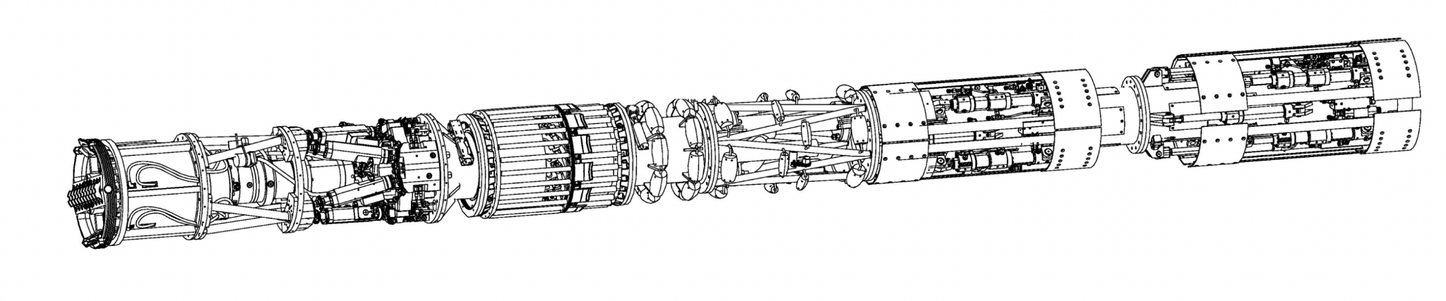

**Dimensions**

Length: 7m

Mass: 2.5t

Diameter: 0.56m

Propulsion force: max. 200kN (= 20 metric tons (weight of a large bus))

Motor speed: max. 3600rpm (About the same as Boeing 747 turbine blade)

Rotation Speed of Cutterhead: 27rpm

Target Speed: 1cm/s

**Erosion**

The erosion system cuts out large stones using the customly designed cutting wheel. Subsequently, it crushes those stones to smaller sizes (1-2 centimeters) using the cone crusher. The tungsten-carbide coating ensures longevity and enables the crusher to get a better grip. In the last step, all the slurry is washed out of the erosion chamber using 10bar water pressure and a Venturi vacuum pump which can be found in the back of the machine. With a torque of 8.5kNm, a rotation speed of 27 rpm and a pushing force of 100kN Swissloop Tunneling is prepared for any soil conditions that could come Groundhog Alpha’s way.

**Steering**

In order to dig curved tunnels, an innovative custom-made hydraulic hexapod system is used. With six hydraulic high-precision cylinders it’s possible to move the cutter head in six degrees of freedom. With our custom software, we can put the machine in jackhammer mode, allowing for strong vibrations through frequencies as high as 20Hz.

**Liner**

To create a tunnel wall, a special polymer 3D-printer is built into the machine. Using tough glass fibre lamellas and a two-component polymer mix, it is possible to create a 15mm thick and highly reliable tunnel wall to ensure structural integrity along the whole length of the tunnel.

**Propulsion**

In the propulsion section sixteen coordinated, high-performance hydraulic cylinders press bracing plates against the tunnel wall in a continuous fashion allowing uninterrupted movement and a propulsion force of max. 200kN.

**Starting Platform**

Starting from the surface the team will not have to dig a starting pit, enabling Groundhog Alpha to start digging down straight away, saving valuable time. The starting platform absorbs all the propulsion forces and acts as an initial guidance system for the machine.

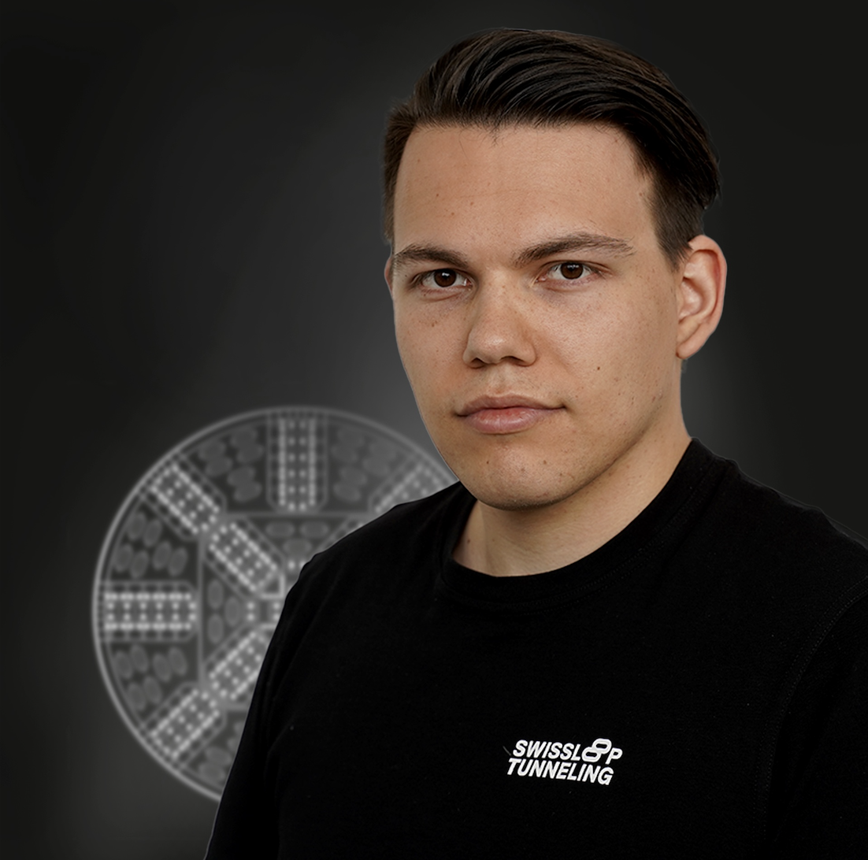Ein Bild, das Person, Wand, drinnen, lächelnd enthält.
**Contact us**Ein Bild, das Person, drinnen, haltend, darstellend enthält.

**Stefan Michael Kaspar**

Founder &  
President of the Board

+41 78 605 71 82

**info@swisslooptunneling.ch**

**Layla Just**

Head Communication

+41 78 677 79 44

**Theresa Lanschützer**

Media Relations

+41 78 249 18 08